## 结果截图

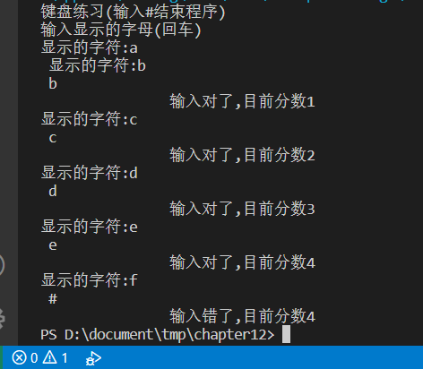

## 代码截图

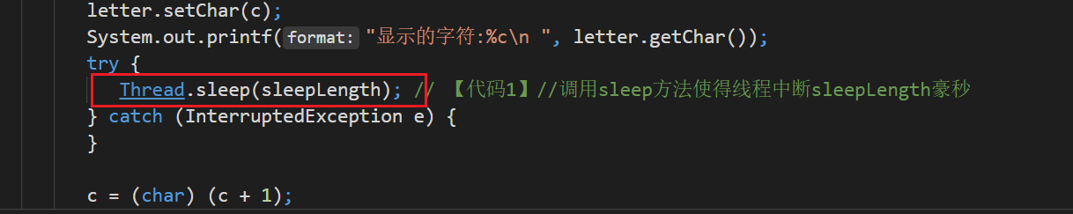

## 源码

public class TypeKey {

public static void main(String args[]) {

System.out.println("键盘练习(输入#结束程序)");

System.out.printf("输入显示的字母(回车)\n");

Letter letter;

letter = new Letter();

GiveLetterThread giveChar;

InuptLetterThread typeChar;

giveChar = new GiveLetterThread();

giveChar.setLetter(letter);

giveChar.setSleepLength(3200);

typeChar = new InuptLetterThread();

typeChar.setLetter(letter);

giveChar.start();

typeChar.start();

}

}

//

public class Letter {

char c = '\0';

public void setChar(char c) {

this.c = c;

}

public char getChar() {

return c;

}

}

//

import java.awt.*;

import java.util.Scanner;

public class InuptLetterThread extends Thread {

Scanner reader;

Letter letter;

int score = 0;

InuptLetterThread() {

reader = new Scanner(System.in);

}

public void setLetter(Letter letter) {

this.letter = letter;

}

public void run() {

while (true) {

// System.out.printf("输入显示的字母(回车)\n"));

String str = reader.nextLine();

char c = str.charAt(0);

if (c == letter.getChar()) {

score++;

System.out.printf("\t\t输入对了,目前分数%d\n", score);

} else {

System.out.printf("\t\t输入错了,目前分数%d\n", score);

}

if (c == '#')

System.exit(0);

}

}

}

//

public class GiveLetterThread extends Thread {

Letter letter;

char startChar = 'a', endChar = 'z';

int sleepLength = 5000;

public void setLetter(Letter letter) {

this.letter = letter;

}

public void setSleepLength(int n) {

sleepLength = n;

}

public void run() {

char c = startChar;

while (true) {

letter.setChar(c);

System.out.printf("显示的字符:%c\n ", letter.getChar());

try {

Thread.sleep(sleepLength); // 【代码1】//调用sleep方法使得线程中断sleepLength豪秒

} catch (InterruptedException e) {

}

c = (char) (c + 1);

if (c > endChar)

c = startChar;

}

}

}